N A R F E
NATIONAL ACTIVE AND RETIRED FEDERAL EMPLOYEES ASSOCIATION

Charles R. Patton Chapter 156 Newsletter
75 Wembly Road, Asheville, NC 28804-1607 April 2014
Dave Wright  President  828-712-8636  dwright@morrisbb.net  Ted Mathis  Legislative Officer  298-4400  ellen1114@charter.net | Sabine Dieringer  1st VP/Membership  236-0080  sabdier@charter.net  Bety Downey  Benevolence  299-1936  downeybc@bellsouth.net | Larry Rhodes  2nd VP/Public Relations/  505-1273  lrho@charter.net  Theron Rumsey  Interim Editor/Past President  828-337-5134  theronrumsey@gmail.com | Jan Rhodes  Treasurer  505-1273  jcrho@charter.net  Lucille Lamy  Newsletter Asst.  298-8410 | Tom Beatty  Secretary  tkbpop@yahoo.com  Dan Louderback  Logistics  645-9350 | Service Officer  Vacant

The National Active and Retired Federal Employees Association (NARFE) is the only association dedicated to safeguarding and enhancing the benefits of America's active and retired federal employees, and their survivors.

EVENT: CHARLES R. PATTON CHAPTER 156 APRIL CHAPTER MEETING
WHEN: SATURDAY, APRIL 12, 2014

WHERE: J&S CAFETERIA, RIVER RIDGE SHOPPING CENTER, 800 FAIRVIEW ROAD
TIME: BREAKFAST AT 9:30 AM, MEETING WILL BEGIN AT 10:15 AM
PROGRAM: “IDENTITY THEFT: WHAT YOU NEED TO KNOW”

APRIL CHAPTER MEETING
You will not want to miss this important, informative, and useful meeting. The program for the April Membership meeting will be presented by Tom and Barbara Morgan, Carolina Fiduciary Services LLC on the topic “Identity Theft: What You Need to Know”. The program will include a Power Point presentation, short ID theft quiz, definitions and examples of ID theft, and available resources for those who want more information. You will also receive a free booklet from the FTC titled “Taking Charge, What to Do if Your Identity is Stolen”. This security issue is critical for us all. As an example, I recently learned of a person having their checking account compromised twice in one year after using their debit card. Current technology that we may take for granted is not totally safe.
This April Chapter meeting is important for a second reason: MEMBERSHIP. Your Executive Committee sets the A;pril Chapter meeting to introduce NARFE to potential member, and to reintroduce NARFE to those folks that may reinstate their membership. You may know friends or family members that are prospecitve members. We hope to see you at the meeting and be sure to bring a potential member.
◊◊◊◊◊◊◊◊◊◊◊◊◊◊◊◊◊◊◊◊◊◊◊◊◊◊◊◊◊◊◊◊◊◊◊◊◊◊◊◊◊◊◊◊◊◊◊◊◊◊◊◊◊◊◊◊◊◊◊◊◊◊
MEMBERSHIP NEWS
NARFE has reported that the chained CPI will not be included in President Obama’s 2015 budget. NARFE has stated that using the chained CPI for calculating COLAs would be a change in the wrong direction, particularly for seniors. Chained-CPI would result in lower COLAs, decreasing the ability to keep up with inflation. However, the next step includes negotiations as the budget moves through Congress. This statement is supported by an article in the Federal Times (http://www.federaltimes.com/article/20140306/AGENCY04/303060014/Door-left-open-chained-CPI comeback?odyssey=nav|head).
The NARFE Legislative Update is encouraging all to write to their Congress reps to head off efforts to impose the Chained CPI. I urge you to NOT use the NARFE canned letter as it includes data from their faulty model. See my previous articles on this or contact me if you want to use believable numbers.
Also I see that our U.S. President wishes to give Federal employees a 1% pay raise in the 2015 budget. To me, with the impact of inflation on our household budgets, that may allow for one added breakfast at McDonalds each month.
Tom Beatty, Chapter Secretary
◊◊◊◊◊◊◊◊◊◊◊◊◊◊◊◊◊◊◊◊◊◊◊◊◊◊◊◊◊◊◊◊◊◊◊◊◊◊◊◊◊◊◊◊◊◊◊◊◊◊◊◊◊◊◊◊◊◊◊◊◊◊
UPCOMING CLUSTER EVENTS
(Note: You are invited to attend any or all of the Clusters.)
COFFEE CLUSTER (EAST)
The East Cluster will meet Thursday April 3 at the J&S Cafeteria, River Ridge Shopping Center at 11:00 AM. Call Ted Mathis (298-4400) for info.
COFFEE CLUSTER (NORTH)
The North Cluster will meet at the Potato Wedge, 1469
Merrimon Ave. on Thursday April 17 at 9:00 AM. Drop in and stay in touch over a cup of coffee or maybe breakfast. Call Theron Rumsey (828-337-5134) for information.
COFFEE CLUSTER (WEST/SOUTH)
The West/South Cluster that typically meets at Ryan’s Family Steakhouse, 1000 Brevard Road near Biltmore Square Mall, will not meet this month in Lieu of our Chapter meeting on the same day and time. We hope to see you at the Chapter meeting.
◊◊◊◊◊◊◊◊◊◊◊◊◊◊◊◊◊◊◊◊◊◊◊◊◊◊◊◊◊◊◊◊◊◊◊◊◊◊◊◊◊◊◊◊◊◊◊◊◊◊◊◊◊◊◊◊◊◊◊◊◊◊
CHAPTER LEADERSHIP CHANGE
At the March 6, 2014 Chapter Executive Committee meeting, Tom Beatty notified the Committee of his desire to relinquish his position of 1st Vice President, but agreed to an appointment of Chapter Secretary. The Committee voted to accept the appointment of Tom Beatty as Secretary and the appointment of Sabine Dieringer as 1st Vice President to complete the 2014 year.
◊◊◊◊◊◊◊◊◊◊◊◊◊◊◊◊◊◊◊◊◊◊◊◊◊◊◊◊◊◊◊◊◊◊◊◊◊◊◊◊◊◊◊◊◊◊◊◊◊◊◊◊◊◊◊◊◊◊◊◊◊◊
NARFE’S NC FEDERATION 2014 CONVENTION
Do not miss the opportunity to attend an informative convention, a chance to meet and interact with fellow members from across the State, and face-to-face meetings with experts on issues important to NARFE members. The 58th North Carolina Federation Annual Convention “Respecting the Past – Creating the Future” will be held May 6-8, 2014 at the Gateway Centre 101 Gateway Blvd, Rocky Mount, NC. Hotel accommodations are available at a rate of $77 plus tax per night for single or double occupancy at the Double Tree by Hilton, 651 N. Winstead Ave. (1-252-937-6888) and the Comfort Inn, 200 Gateway Blvd. (1-252-937-7765) Hotels are co-located with the Convention Center. Make reservations directly with the hotel using Convention code “NARFE14”. Reservations must be made by April 1, 2014.
The Convention registration fee after March 1 is $60 (includes $30 for Registration and $30 for Banquet). Send your convention registration to the Convention Treasurer (use form in latest Federation newspaper. The Convention Treasurer is Gracie W Couch, 729 Carriage Trail, Rocky Mount, NC 27804,(Phone: 252- 937-4648. You can also register on line at: (http://www.ncnarfe.info/NewConventionRegister.aspx) . Theron Rumsey
◊◊◊◊◊◊◊◊◊◊◊◊◊◊◊◊◊◊◊◊◊◊◊◊◊◊◊◊◊◊◊◊◊◊◊◊◊◊◊◊◊◊◊◊◊◊◊◊◊◊◊◊◊◊◊◊◊◊◊◊◊◊
CONVENTION CHAPTER DELEGATES
The tentative list of members representing Chapter 0156 as delegates and committee members are Ted Mathis, Sandy and Theron Rumsey, and Mary and David Wright. Contact David Wright (828-712-8636 or dwright@morrisbb.net) if you are interested in attending the convention. Our Chapter is allowed 12 voting delegates and we would like to fill all delegate slots. The Chapter reimburses each delegate to cover the cost of registration. You may want to add a few days to your travel and visit the Outer Banks which is only an easy half-day travel from Rocky Mount.
◊◊◊◊◊◊◊◊◊◊◊◊◊◊◊◊◊◊◊◊◊◊◊◊◊◊◊◊◊◊◊◊◊◊◊◊◊◊◊◊◊◊◊◊◊◊◊◊◊◊◊◊◊◊◊◊◊◊◊◊◊◊
REACH OUT TO ACTIVE EMPLOYEES
NARFE is as critically important to active federal employees as it is to retirees. With this in mind, we are asking members who are active federal employees to share NARFE with your co-workers. We suggest using the NARFE magazine as an information resource. Other information resources are available from our First Vice President (236-0080). Bring a co-worker(s) to the April Chapter Membership meeting. NARFE works to protect your current retirement benefits so they are available at the time of your retirement. ◊◊◊◊◊◊◊◊◊◊◊◊◊◊◊◊◊◊◊◊◊◊◊◊◊◊◊◊◊◊◊◊◊◊◊◊◊◊◊◊◊◊◊◊◊◊◊◊◊◊◊◊◊◊◊◊◊◊◊◊◊◊

DUES WITHHOLDING
Sign up for dues withholding and save. Keep more money in your pocket by saving 15% off of your annual National
membership dues, spouses are also eligible. Join the 126 fellow chapter members who are already getting the savings. One-twelfth of your annual dues is automatically deducted from your monthly annuity, and in addition to saving 15%, you will never get another dues reminder to pay your dues again. You can also cancel your dues at any time. Go to the February issue of the NARFE magazine (pages 35 and 49) for details and application.
◊◊◊◊◊◊◊◊◊◊◊◊◊◊◊◊◊◊◊◊◊◊◊◊◊◊◊◊◊◊◊◊◊◊◊◊◊◊◊◊◊◊◊◊◊◊◊◊◊◊◊◊◊◊◊◊◊◊◊◊◊◊
MEMBER ACTIVITY REPORT - FEB 15 to MAR 15, 2014
New or Reinstated Chapter Members: We welcome the following folks:
Susan Schaffer Irene Harwood Ina Parr
David Wright (not our Chapter President)
Please join us at our chapter events listed in the Newsletter.
Members That Decided to Drop Their Membership:
William Shackelton
We ask any member acquainted with this member to give him a call and encourage him to reinstate his membership.
Prospective Members:
Stephen Del Greco Dongsoo Kim
If you are acquainted with these individuals, please encourage them to join NARFE.
◊◊◊◊◊◊◊◊◊◊◊◊◊◊◊◊◊◊◊◊◊◊◊◊◊◊◊◊◊◊◊◊◊◊◊◊◊◊◊◊◊◊◊◊◊◊◊◊◊◊◊◊◊◊◊◊◊◊◊◊◊◊◊
HUMOROUS OR NOT
"A word to the wise tends to infuriate them!"

NOTE: OUR NEXT NEWSLETTER WILL BE THE MAY 2014 NEWSLETTER. Deadline for articles – APRIL 21, 2014

WE GRATEFULLY ACKNOWLEDGE GROCE FUNERAL HOME AND ASHEVILLE QUICKPRINT FOR THEIR CONTINUING SUPPORT TO NARFE CHAPTER 156.

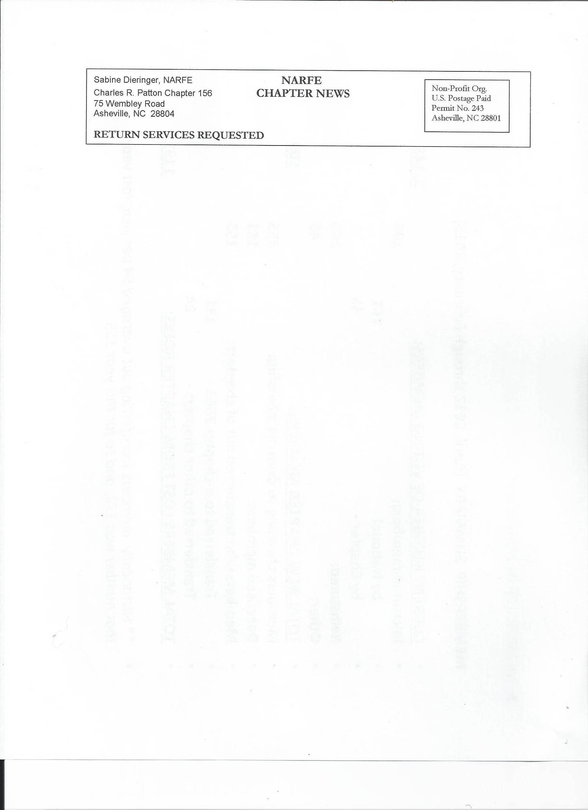

LEGISLATIVE UPDATE
Contact Info for NC Members of Congress
Senator Richard M. Burr: DC Office 202-224-3154, Local Number 350-2437, www.burr.senate.gov
Senator Kay Hagan: 202-224-6342, Local Number, 257-6510,
www.hagan.senate.gov
10th District Congressman Patrick T. McHenry: DC Office 202-225-2576, Black Mountain Office Number 828-669-0600, www.mchenry.house.gov
11th District Congressman Mark Meadows: DC Office 202-225-6401, Local Number 693-5660, www.meadows.house.gov
Ted Mathis, Legislative Officer

